Demographic Characteristics of Students Who Do or Do Not Post in an Undergraduate Engineering Online Forum

| Leave Authors Anonymous  for Submission  City, Country  e-mail address | Leave Authors Anonymous  for Submission  City, Country  e-mail address | Leave Authors Anonymous  for Submission  City, Country  e-mail address |
| --- | --- | --- |

# ABSTRACT

*Please do not modify this text block until you receive explicit instructions.*

Permission to make digital or hard copies of all or part of this work for personal or classroom use is granted without fee provided that copies are not made or distributed for profit or commercial advantage and that copies bear this notice and the full citation on the first page. Copyrights for components of this work owned by others than the author(s) must be honored. Abstracting with credit is permitted. To copy otherwise, or republish, to post on servers or to redistribute to lists, requires prior specific permission and/or a fee. Request permissions from [Permissions@acm.org](mailto:Permissions@acm.org).

*CONF '22,* Jan 1 - Dec 31 2022, Authorberg.

Copyright is held by the owner/author(s). Publication rights licensed to ACM. ACM 978-1-xxxx-yyyy-z/zz/zz…$zz.00.

unique doi string will go here

Online discussion forums have become widely used in undergraduate classrooms. They extend the learning space beyond the classroom and provide asynchronous opportunities for peer-to-peer collaborations. There are studies that suggest posting behavior plays a role in students’ learning outcomes; however, the study of demographic characteristics of students who participate in online discussions is limited. This study compares gender, ethnicity, and international status of students who did and did not participate in an online discussion forum. The demographic variables of interest were chosen based on prior studies that showed varied usage patterns for online tools across gender and ethnic groups. The discussion forum provided a platform, where students could ask or answer their peers’ questions about the course material and homework assignments. The setting for this study was a sophomore-level dynamics and vibrations class that incorporated active, blended, and collaborative learning strategies. We were able to track an individual’s posting behavior with the website software. Study participants were grouped by whether they posted to the discussion forum at least once or not, and the Fisher’s exact test was used to determine the statistical significance of demographic differences across the participation groups. It is shown that female students are more likely to be involved in online discussions than their male counterparts. Also, White and American Asians are overrepresented but international students are underrepresented in the engaged group. This work extends our knowledge of who uses online collaboration tools, and future work will analyze the content of the posts and explore the influence of forum participation on grades via a regression model.

## Author Keywords

Online Discussion Forums; Demographic Characteristics; Gender; Ethnicity.

## ACM Classification Keywords

H.5.m. Information interfaces and presentation (e.g., HCI): Miscellaneous; See<http://acm.org/about/class/1998> for the full list of ACM classifiers. This section is required.

# INTRODUCTION

The current schooling norm is that students have access to help during the class hours and limited office hours. They are not in touch with their instructors or classmates outside of the class. The introduction of an online discussion forum for a class helps students connect with their peers, teaching assistant (TA), and even instructors outside of the class and office hours. Such a discussion forum provides a public space, where ideas can be exchanged, questions can be shared, and information can be stored. Students can help each other clarify doubts with fewer time and space limits.

In this paper, we investigate how participation on the forum relates to the students’ demographic characteristics. Studies in collaborative learning have shown that differences in participation can be traced to many factors, such as pre-knowledge, social background and gender. Some studies in Computer Media Communication (CMC) have shown that different levels of participation related to learner characteristics.

In this study, we explore whether or not differences occur in the participation of students who differ in gender, international status, ethnicity and declared major. We also investigate gender distribution under different levels of participation, since studies have shown that the differences found often concern gender differences.

# Research question

The investigation is based on the following research questions:

1. How do students’ demographic characteristics relate to the number of their posts?

2. Among students who participate, how do students’ demographic characteristics relate to the number of their posts?

We expect that there is a strong relationship between students’ demographic characteristics and participation level. Among the demographic characteristics we are interested, we expect that female students to have higher rates of participation in the online discussion forum compared with male students because many related researches stated that females send more messages to the discussions than males do[1]. We also expect that international students feel less comfortable discussing their questions in such a public, online space, so we expect them to be underrepresented in forum participation. Since the course material is closest to mechanical engineering, we expect more ME students to be active in online discussion than students from other majors.

Regarding to the second question, we expect that the density of female students of higher number of posts should be over male students. Our hypothesis is based on previous work, more details will be discussed in the following literature.

# Related Literature

## What Are Online Discussion Forums?

An online discussion forum is a virtual environment where students can communicate with their peers and instructors without temporal or geographical barriers [3][9]. Recently, academic online discussion forums have become more and more popular among undergraduate courses due to their asynchronous nature [10]. Asynchronous communication does not require simultaneous participation of all students and instructors. They can post or respond messages at any time and at any place working best for them. Besides, they can also view the messages many times after they are posted. Also, it is an effective mode for critical thinking and analysis. This is because it facilitates critical thinking by writing down the thoughts and things learnt in the course. Due to these advantages, the popularity of using asynchronous online discussion forum is foreseen.

Currently, the asynchronous online discussion forums are also contemporary tools that can save, arrange and present the message into various discussion threads. Participation in asynchronous online forums can be identified as an indicator to evaluate the level and progress of interaction in online discussion.

Learner participation has been discussed widely as a critical part of learning process. It is a prerequisite of interaction to maximizing learning. Researchers expressed that participation affects perceived positively learning, achievement, and satisfaction in the literature [2]. For example, Minichiello and Hailey (2013) have suggested that engaging in online learning forums is highly correlated to students’ performance in first-year calculus [3]. Cheng et al. suggest that the implementation of an online discussion forum benefited students because they demonstrate that online collaborative learning reflected improved academic outcomes. Another study was conducted to analyze discussion in an online course by Picciano who found that students perceived greater quality and quantity of learning as a result of participating in the discussions [4].

Most studies regarding students’ engagement in online discussion forums focus on the motivational influence on students’ academic behavior. Only limited studies have focused on the relationship of students’ demographic characteristics and their level of engagements. For instance, in a case study of a social online discussion forum, Yeh et.al. studied the participation of users based on their gender, nationality and age [3]. They found that more than half of the users were female (53%), and half of the users were between the ages of 16-30. Ke. et al. complete a study on how students’ ethnicity affects their level of participation in an online learning forum and concluded that students’ minority status correlated with lower satisfaction with the web-based, distance-learning class. Another study conducted to analyze this relationship by Yukselturk who revealed that students’ participation level in discussion forum was significantly related with student gender and weekly hours of Internet use. It also showed that there was no relationships between students’ participation level in discussion forum and age, education level, prior web-based learning experience and domain knowledge [5]. One more study by Prinsen, Volman, and Terwel stated that females send more messages to the discussions than male do. They also mentioned that students who are good at comprehensive reading also send more messages. Another variable that influences the degree of participation is popularity among classmates. However, some studies, like the study was conducted by Wu. And Hiltz. In 2004, have showed that there will be no difference between female and male students in perceptions of learning, motivation and enjoyment from online discussions.

In a summary, the importance of participation and interaction in education especially in online discussion is extensive in the literature. However, most of the demographic related studies on academic forums have examined public learning or social forums influence, instead of a discussion forum only focusing on a face-to-face based class. Over 50 US online learning program directors responded to a survey in 2002 and projected that the proportion of their students enrolled in totally online courses would increase from 20.2% to 36.6% in the next few years, but those enrolled in “blended” courses, which points at students learning from asynchronous online discussions that were conducted in addition to face-to-face meetings of the classes, would increase even faster, from 7.6% to 21.1%. It is more interesting to study if students’ demographic characteristics make a difference in the level of engagement under the circumstance that students have the chances to meet with peers and instructors face to face during class time or office hours. As a result, the relationship between participation and interaction and learning outcomes is a complex phenomenon and we need more studies related to this phenomenon.

In our study, the discussion forum we chose was incorporated as part of the class website for a sophomore-level dynamics and vibration class that incorporated active blended, and collaborative learning strategies. Students used the forum to communicate with their classmates regrading homework questions, example problems, or other course content.

# Research Method

In this session, we depict the sample data and the features we used for analysis.

## Data Collection

This mechanical engineering (ME) course forum assigns each post a unique id. As long as students write a message, their posts are recorded under the student school id. Part of the post related information is extracted into a csv file by a software tool. This includes the person id, which person this post is communicated with, and the post time. In our situation, the instructor always starts a new thread by posting homework problems or lecture notes, and students can post their doubts or opinions under the instructor’s post. Since we are only interested in students’ online social behavior, the posts started with an instructor has been removed.

Particularly in this paper for the context of evaluating student’s online discussion performances, we will use out-degree centrality to count the number of messages sent by a student. If a student acquires high number in out-degree, it indicates that he or she is more active in sending messages to others. There were 954 unique students participated in our course’s online discussion board and total number of messages have been sent was 1861 in three academic semester from 2015-2016. These included students’ posts and replies, but initial posts from instructors and teaching assistants were not included.

## Variable

The dependent variable was if the students participated in discussion forum of the dynamic course. If a student’s out-degree is bigger or equal than 1, we count him or her as a participant, otherwise we count as a non-participant.

Students’ demographic characteristics (gender, nationality, ethnicity, and majors) were independent variables. The list of independent variables, description and categories of these variables are presented in Table 1. As mentioned previously in online discussion forum session, this class is about dynamics and vibration, which is required for mechanical engineering (ME), selective for Agriculture Engineering (AAE), Nuclear Engineering (NE). Students from Multidiscipline Engineering Study, Biomedical Engineering can also take this class for credits, so I summarize them as “Others”.

## Collection

Models based on demographic attributes are important since it helps to determine the connectivity based on social attributes [7]. Demographic characteristics (e.g. gender, ethnicity, major) of the participants were obtained from the application forms they filled out while consented for joining this program. After the course started, the pre-test was administered to collect students’ prior knowledge. There are totally 885 out 954 students have consented to join the study, among which 360 are participants, and 379 are nonparticipants. Three data frames of user personal profile data plus the number of out-degrees are generated via R. One is of consented participants, one is of non-participants, and the other one is of total students. Each data frame contains belonging students’ demographic information. Manual validation check is applied. For example, we manually counted the number of students who posted below 5 times, as a result it matches the outcomes that R calculated. Statistical graphics are generated for each perspective of selected demographic pattern among how frequently a person posts online. Last but not at least, chi-square Independent test is applied. This test allows us to test whether the observed proportions for a categorical variable differ from hypothesized proportions [5].

[1].

|  |  |  |
| --- | --- | --- |
| Variable | Description | Categories |
| Gender | Sex of students | Male Female |
| Nationality | The citizenship of students | Domestic(USA) International |
| Ethnicity | The state of students’ belongings to a social group | White  Asian American  Hispanic or Latino  African American  Unknown  2 or more races |
| Major | Students’ main area of study when taking the course. | Mechanical Engineering(ME)  Agriculture Engineering(AAE)  Nuclear Engineering(NE)  Others |

## Table 1. Description and Categories of Independent Variables

# Result and analysis

The results of the study will be reported in two research questions separately.

## Gender Distribution

From the figure 1, we can see that 23.89% of discussion participants are female students. The percentage value is less than that of male students due to the unbalanced ratio of this engineering class. From the third column, we can see that the whole class only have 17.54% of female students. More than half of the female students get involved in this online discussion forum more or less. There are 76.11% of participants are men but 82.49% of total class students are male students. Therefore, female students are relatively more active in participating in online discussion forum. The gender distribution is similar to the result from previous studies[3][6], where they declared that women are more active than male students on social network media and online discussion blog.

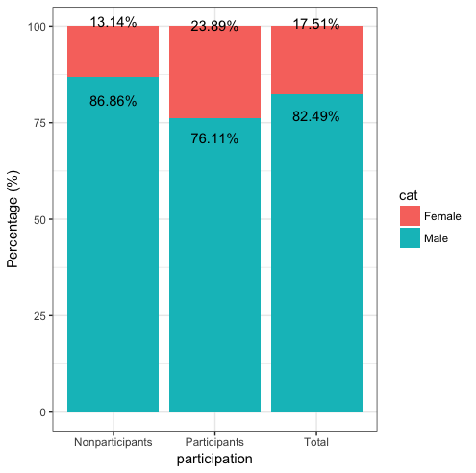

Figure . Student gender distribution among participants, nonparticipants and total. It is shown that 23.89% participants are female students. Compared with the total female students’ ratio, they are more active in online discussion forum than their male counterparts

## Ethnicity Distribution

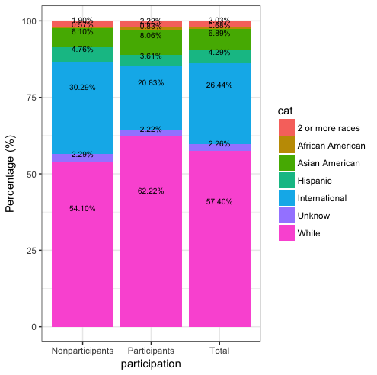

Figure 2. Students’ Ethnicity Distribution. Among different ethnic group, white and Asian American students are very engaged in the discussion forum; However, international students (non-US citizens) and Hispanic or Latinos communicate less with their peers online.

Figure. 2 above shows the nationality and ethnicity distribution of the sample data. Our total data shows that the white American people dominate the population, followed by International students, Hispanic, and Asian Americans. There are 57.40 % of the class students are white American. Among all participants, 62.22% are the whites, and 54.10% of nonparticipants are white people. From these data, we can see that white Americans over-represented. Next, from column three, we can see that 26.44% of the class students are internationals, but this ratio decreases to 20.83% in participants column. As a result, international students look under-represented in this forum. Moreover, there are 4.29% of the class students are Hispanic or Latino and 6.89% are Asian Americans. The ratio of Hispanic students in participants column decreases to 3.61% but the ratio of Asian Americans increases to 8.06%. Then we can say that Hispanics less involved but Asian Americans are more involved in this online forum. Therefore, White Americans and Asian Americans are over-represented but international students and Hispanics are under-represented. This matches one of the previous work[3], where they declared that minority status has lower satisfaction with the web-based distance study. In this case, we did not look into African American, 2 or more races, and Unknown students since the sample data is very small.

## Major Distribution

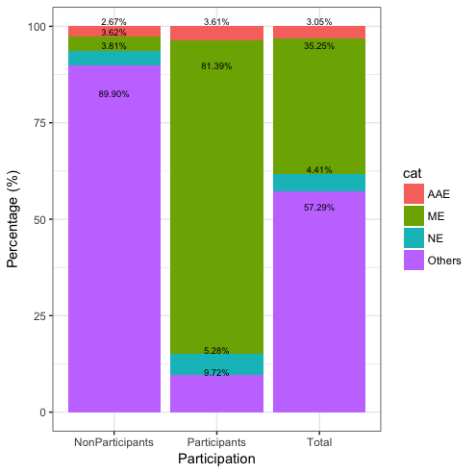

Figure 3. Major Distribution among participants, nonparticipants and all students. ME represents Mechanical Engineering, AAE represents Agriculture Engineering, NE represents Nuclear Engineering. From the graph, it is obvious that ME students are the most involved group. NE and AAE students also participate in discussion, but students who take this course for credits, are very unlikely communicate with their peers online.

Figure 3 shows the major structure of the sample data. This online discussion forum is designed for a dynamic course, so all students are directly from mechanical engineering(ME), Agriculture Engineering(AAE), Nuclear Engineering, and other engineering departments, where students can take this course as a selective. Among those, ME students are the majorities, after are NE, AAE and others. From the graph, we can see that there are total 39.92% ME students, but 81.39% of participants are MEs. We can see that ME students are very active involved. There are totally 3.92% NE students, and 5.28% are among participants. Therefore, NE students also interact with their peers actively. There are 2.98% of total students from Agriculture Engineering, and they take 3.61% off total participants. We can see that AAE students are over-represented. Last there are 53.18% of students from other engineering department, who take this course only for credits. The ratio of participants in participants’ group decreases to 9.72%, and the ratio of nonparticipants increases to 94.46%, so students taking this course only for credits are very under-represented. Therefore, we can conclude that students from ME, NE and AAE for whom this course is mandatory or selective are more involved in this online discussion forum, but students from other engineering department are less involved.

## Chi Square Independent Test

In order to examine first research questions, the demographic relationship was tested by two-way contingency table analysis (Chi-square for independence). Before testing the hypothesis, categories were combined to satisfy the test assumption that expected counts in all cells were greater than or equal to 5.

The chi-square test revealed that students’ participation status in discussion forum was found to be significantly related with student gender (Pearson x2 (df = 1, N = 885) = 17.071, p = 3.62e-05, Cramer’s V = 0.182), ethnicity (Pearson x2 (df = 3, N = 841) = 11.529, p = 0.0092, Cramer’s V = 0.1939), and students’ major area of study (Pearson x2 (df = 3, N = 885) = 475.09, p = 2.2e-16, Cramer’s V = 0.8287). Students’ major variable had the most effect on participation status of online discussion (Cramer’s V = 0.8287). Table 2 summarizes individual characteristics showing significant association with students’ participation status.

## Gender Distribution

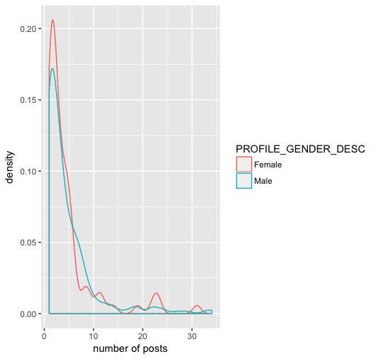

**Figure 4. Gender Distribution among the number of posts**

The figure above shows the gender density trend among all participants. We can obviously see that women have a higher peak value at lower number of posts (0 - 5) and medium-high posts (20 - 25). Here we didn’t count one student, who posts 150 times over one semester, in order to keep the trend line more appropriate to describe the situation.

# Discussion

Communication and interaction has recently been accepted as a way to increase the quality of instruction. In other words, one of the key components of good reflection after teaching is meaningful interaction with peers and teacher. Students’ participation is a prerequisite for supplying interaction and communication in online discussion forum. There are number of factors affecting participation in asynchronous discussion that provides a platform for peers to argue with course material. The study examined demographic factors affecting student participation and interaction in an academic discussion forum. From those demographic characteristics, only three of them (gender, ethnicity, major) have been studied based on previous works and showed a significant relationship with student participation status in discussion forum. Also, female students are found to be more dense than male students in active and moderate participation level.

|  |  |  |  |  |  |  |
| --- | --- | --- | --- | --- | --- | --- |
| **Variable** | **P.Level** | **Female** | **Male** | **X2** | **P** | **Cramer’s V** |
|  | **Participants** | **86** | **274** | **16.33** | **3.62e-05** | **0.1389** |
| **Gender** | **Nonparticipants** | **69** | **456** |  |  |  |
|  | **Total** | **155** | **730** |  |  |  |

|  |  |  |  |  |  |  |  |  |
| --- | --- | --- | --- | --- | --- | --- | --- | --- |
|  |  | White | Asian American | International | Hispanic |  |  |  |
|  | Participants | 224 | 29 | 75 | 13 | 11.529 | 0.0092 | 0.1939 |
| Ethnicity | Nonparticipants | 284 | 32 | 159 | 25 |  |  |  |
|  | Total | 508 | 61 | 234 | 38 |  |  |  |
|  |  | ME | NE | AAE | Others |  |  |  |
| Major | Participants | 293 | 19 | 13 | 35 | 607.72 | <2.2e-16 | 0.8287 |
|  | Nonparticipants | 19 | 20 | 14 | 472 |  |  |  |
|  | Total | 312 | 39 | 27 | 507 |  |  |  |

Table 2: Individual Characteristics Showing Significant Association with Participation status

According to the statistical results of this study, there is a significant difference between participation or no-participation regarding gender in discussion forum. The result of this study has confirmed that female students are generally more active in participating in online discussion than males. In the literature, gender based differences in online education have been recognized as an important focus for research for a long time. When reviewing gender related studies, the effects of this variable are inconclusive. On the other hand, some studies reported that female students developed higher collaboration in online discussion than male students [][]. However, Ory, Bullock and Burnaska examined gender difference in 1997, in use of an asynchronous communication about one year in a university setting and did not find any difference.

A result of the study confirmed that there is a significant difference between the participation levels regarding gender in discussion forum [13]. Results showed that the number of active female students are (45.3%) higher than males (28.7%), but the moderate active female students were lower than males in discussion forum.

# Limitation

The generalizability of our findings is limited in many ways. Only one course and couple semesters were included in one public university. We need to compare these results to those for totally online courses and others from different backgrounds. The measurement is

A measure of ethnicity role should have more sample data on African American and 2 more races to make conclusions. In the current study, only White American, Asian American, International and Hispanic variables were measured.

# Conclusion

# In this paper, social network analysis combined with statistical graphics and validation check have been used to understand demographics of students who do or do not participate in online discussion forums. It is shown that female students are more likely to be involved than their male counterparts. Also, White and American Asians are overrepresented but international students are underrepresented in the engaged group. Future work will analyze the content of posts based on couple case studies and explore the influence of forum participations on grades via a regression model.

# ACKNOWLEDGMENTS

Sample text: We thank all the volunteers, and all publications support and staff, who wrote and provided helpful comments on previous versions of this document. Authors 1, 2, and 3 gratefully acknowledge the grant from NSF (#1234-2012-ABC). This is just an example.

# References format

Your references should be published materials accessible to the public. Internal technical reports may be cited only if they are easily accessible and may be obtained by any reader for a nominal fee. Proprietary information may not be cited. Private communications should be acknowledged in the main text, not referenced (e.g., [Golovchinsky, personal communication]). References *must* be the same font size as other body text. References should be in alphabetical order by last name of first author. Use a numbered list of references at the end of the article, ordered alphabetically by last name of first author, and referenced by numbers in brackets. For papers from conference proceedings, include the title of the paper and the name of the conference. Do not include the location of the conference or the exact date; do include the page numbers if available. References should be in ACM citation format: <http://acm.org/publications/submissions/latex_style>. This includes citations to internet resources [1,4,9] according to ACM format, although it is often appropriate to include URLs directly in the text, as above. Example reference formatting for individual journal articles [3], articles in conference proceedings [7], books [10], theses [11], book chapters [12], an entire journal issue [6], websites [1,4], tweets [1], patents [5], games [8], and online videos [9] is given here. This formatting is a slightly edited version of the format automatically generated by the ACM Digital Library (http://dl.acm.org) as “ACM Ref”. DOI or URL links, and authors’ full first names, are optional but encouraged. Do your best! Your paper won’t get rejected for not having DOI links or authors’ first names. Note that the Hyperlink style used throughout this document uses blue links; however, URLs in the references section may appear in black.

# REFERENCES

1. Prinsen, F., Volman, M.L.L., Terwel, J. 2007, The Influence of Learner Characteristics on Degree and Type of Participation in a CSCL Environment. *British Journal of Educational Technology*, 38(6), 1037-1055.
2. Hrastinski, S. 2008. What is Online Learner Participation? *Computers & Education*, 51(4), 1755-1765
3. R. E. Anderson. 1992. Social impacts of computing: Codes of professional ethics. *Soc Sci Comput Rev* 10, 2: 453-469.
4. Picciano, A.G. 2002. Beyond Student Perceptions: Issues of Interaction, Presence, and Performance in An Online Course. *Journal of Asynchronous Learning Networks*, 6(1), 2140.
5. Yukselturk, E. 2010. An Investigation of Factors Affecting Student Participation Level in An Online Discussion Forum. *The Turkish Online Journal of Educational Technology*. Vol 9.
6. Jofish Kaye and Paul Dourish. 2014. Special issue on science fiction and ubiquitous computing. *Personal Ubiquitous Comput*. 18, 4 (April 2014), 765-766. <http://dx.doi.org/10.1007/s00779-014-0773-4>
7. Scott R. Klemmer, Michael Thomsen, Ethan Phelps-Goodman, Robert Lee, and James A. Landay. 2002. Where do web sites come from?: capturing and interacting with design history. In *Proceedings of the SIGCHI Conference on Human Factors in Computing Systems* (CHI '02), 1-8. <http://doi.acm.org/10.1145/503376.503378>
8. Nintendo R&D1 and Intelligent Systems. 1994. *Super Metroid*. Game [SNES]. (18 April 1994). Nintendo, Kyoto, Japan. Played August 2011.
9. Psy. 2012. Gangnam Style. Video. (15 July 2012.). Retrieved August 22, 2014 from <https://www.youtube.com/watch?v=9bZkp7q19f0>
10. Marilyn Schwartz. 1995. *Guidelines for Bias-Free Writing.* Indiana University Press.
11. Ivan E. Sutherland. 1963. *Sketchpad, a Man-Machine Graphical Communication System*. Ph.D. Dissertation. Massachusetts Institute of Technology, Cambridge, MA.
12. Langdon Winner. 1999. Do artifacts have politics? In *The Social Shaping of Technology* (2nd. ed.), Donald MacKenzie and Judy Wajcman (eds.). Open University Press, Buckingham, UK, 28-40.
13. Yukselturk, E., An Investigation of Factors

**Columns on the last page should be of approximately equal length. Remove this line before submission.**

1. Use footnotes sparingly, if at all.